LAB WORKSHEET 04

**Q01.**

**Code:**

public class Q01 {  
 public static void main(String[] args) {  
 Scanner input =new Scanner(System.*in*);  
 System.*out*.println("Enter the three integers: ");  
  
 int num1= input.nextInt();  
 int num2= input.nextInt();  
 int num3= input.nextInt();  
  
 int smallest = num1;  
 if(num2<smallest){  
 smallest=num2;  
 }  
 if(num3<smallest){  
 smallest=num3;  
 }  
 System.*out*.println("smaller number is " + smallest);  
  
 }  
}

**Output:**

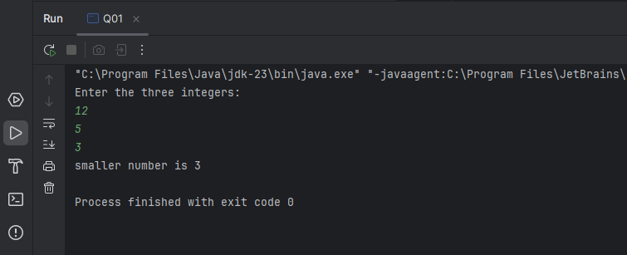

**Q02.**

**Code:**

package Q2;  
  
import java.util.Scanner;  
  
public class Q02 {  
 public static void main(String[] args) {  
 Scanner input=new Scanner(System.*in*);  
 System.*out*.println("Enter a number between (0-4)");  
 int number = input.nextInt();  
 String color;  
 switch(number) {  
 case 0:  
 color = "magenta";  
 break;  
 case 1:  
 color = "Cyan";  
 break;  
 case 2:  
 color = "Red";  
 break;  
 case 3:  
 color = "Blue";  
 break;  
 case 4:  
 color = "Green";  
 break;  
 default:  
 color = null;  
 break;  
 }  
 if(color==null){  
 System.*out*.println("Invalid selection ");  
 }else  
 System.*out*.println("you selected "+ color);  
 }  
}

**Output:**

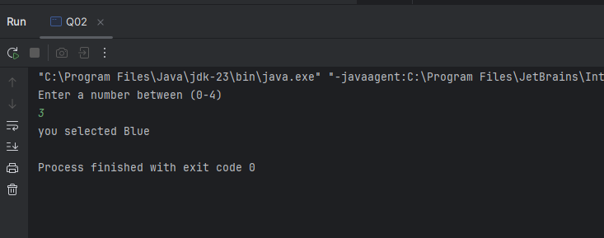

**Q03.**

**Code:**

package Q03;  
  
import java.util.Scanner;  
  
public class Q03 {  
 public static void main(String[] args) {  
 System.*out*.println("6 Million ");  
 System.*out*.println("9 Billion ");  
 System.*out*.println("12 Trillion");  
 System.*out*.println("15 Quadrillion");  
 System.*out*.println("18 Quintillion");  
 System.*out*.println("21 Sextillion ");  
 System.*out*.println("30 Nonillion ");  
 System.*out*.println("100 Googol");  
  
 Scanner scanner =new Scanner(System.*in*);  
 System.*out*.println("input the 10th power");  
 int power=scanner.nextInt();  
 String message = new String();  
 switch(power){  
 case 6:  
 message="Million";  
 break;  
 case 9:  
 message="Billion";  
 break;  
 case 12:  
 message="Trillion";  
 break;  
 case 15:  
 message="Quadrillion";  
 break;  
 case 18:  
 message="Quintillion";  
 break;  
 case 21:  
 message="Sextillion";  
 break;  
 case 30:  
 message="Nonillion";  
 break;  
 }  
 if(message==null){  
 System.*out*.println("Invalid input");  
 }  
 else{  
 System.*out*.println("Your selection "+ message);  
 }  
 }  
 }

**Output:**

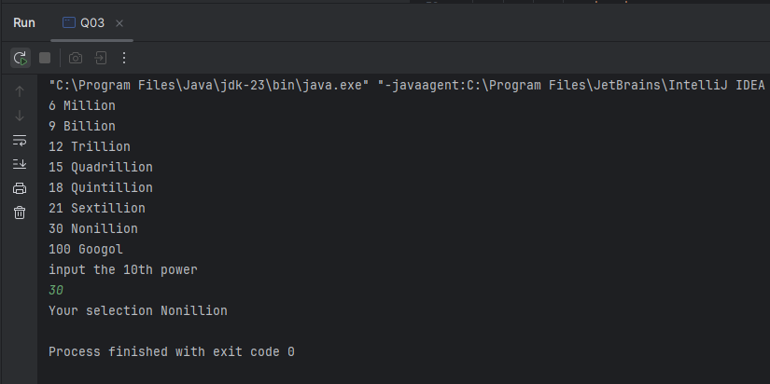

**Q04.**

**Code:**

public class Q04 {  
 public static void main(String[] args) {  
 Scanner scanner=new Scanner(System.*in*);  
 System.*out*.println("Enter the year ");  
 int year=scanner.nextInt();  
 if((year%4==0)&&(year%100==0)){  
 if(year%400==0){  
 System.*out*.println("It is a leap year:");  
 }  
 else{  
 System.*out*.println("It is not a leap year:");  
 }  
 } else if ((year%4==0)||(year%100==0)&&(year%400==0)) {  
 System.*out*.println("It is a leap year:");  
 }  
 else{  
 System.*out*.println("It is not a leap year:");  
 }  
 }  
}

**Output:**

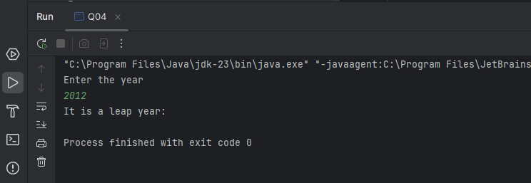

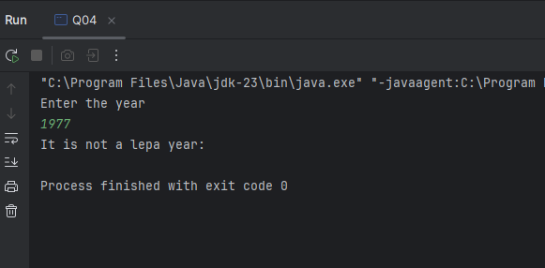

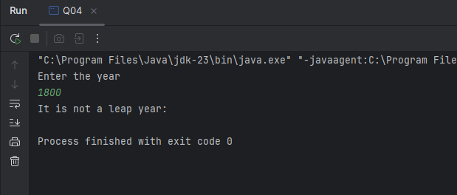

**Q05.**

**Code:**

package Q5;  
  
import java.util.Scanner;  
  
public class Q05 {  
 public static void main(String[] args) {  
 Scanner scanner = new Scanner(System.*in*);  
 double total = 0.0;  
  
 System.*out*.println("Entree: ");  
 System.*out*.println("\t 1.Tofu Burger - $3.49");  
 System.*out*.println("\t 2.Cajun Chicken - $4.59");  
 System.*out*.println("\t 3.Bufffalo Wings - $3.99");  
 System.*out*.println("\t 4.Rainbow Fillet - $2.9\n9");  
  
 System.*out*.println("Side Dish:");  
 System.*out*.println("\t5.Rice Cracker - $0.79");  
 System.*out*.println("\t 6.No-Salt Fries - $0.69");  
 System.*out*.println("\t 7.Zucchini - $1.09");  
 System.*out*.println("\t 8.Brown Rice - $0.59\n");  
  
 System.*out*.println("Drink: ");  
 System.*out*.println("\t 9.Cafe Mocha - $1.49");  
 System.*out*.println("\t 10.Cafe Latte - $1.90");  
 System.*out*.println("\t 11.Espresso - $2.49");  
 System.*out*.println("\t 12.Oolong Tea - $0.99\n");  
  
 System.*out*.println("Enter the Number of item in Entree: ");  
  
 int entree = scanner.nextInt();  
  
 System.*out*.println("Enter the number of item in Side Dish: ");  
 int side = scanner.nextInt();  
  
 System.*out*.println("Enter the Number of item in Drink: ");  
 int drink = scanner.nextInt();  
  
 if (entree == 1) {  
 System.*out*.println("you selected entree as Tofu Burger");  
 total = total + 3.49;  
 } else if (entree == 2) {  
 System.*out*.println("you selected entree as Cajun Chicken");  
 total = total + 4.59;  
 } else if (entree == 3) {  
 System.*out*.println("you selected entree as Buffalo Wings");  
 total = total + 3.99;  
  
 } else if (entree == 4) {  
 System.*out*.println("you selected entree as Rainbow Fillet");  
 total = total + 2.99;  
  
 }  
 if (side == 5) {  
 System.*out*.println("you selected entree as Cajun Chicken");  
 total = total + 0.79;  
 } else if (side == 6) {  
 System.*out*.println("you selected entree as No-Salt Fries");  
 total = total + 0.69;  
 } else if (side == 7) {  
 System.*out*.println("you selected entree as Zucchini");  
 total = total + 1.69;  
  
 } else if (side == 8) {  
 System.*out*.println("you selected entree as Brown Rice");  
 total = total + 0.59;  
 }  
 if (drink == 9) {  
 System.*out*.println("you selected drink as Cafe Mocha");  
 total = total + 1.99;  
 } else if (drink == 10) {  
 System.*out*.println("you selected drink as Cafe Latte");  
 total = total + 1.90;  
  
 } else if (drink == 11) {  
 System.*out*.println("you selected drink as Espresso");  
 total = total + 2.49;  
 } else if (drink == 12) {  
 System.*out*.println("you selected drink as Oolong Tea");  
 total = total + 0.99;  
 }  
 System.*out*.println("Your total bill: " + total);  
 }  
}

**Output:**

